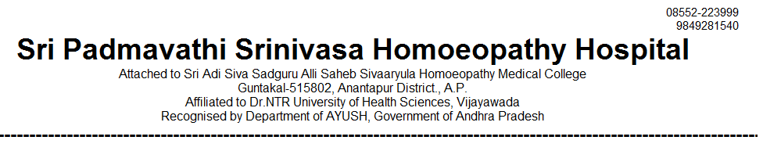
OUT PATIENT STATEMENT FOR THE YEAR JAN-2023 TO DEC - 2023

SNO | MONTH | GENERAL MEDICINE | GYNAECOLOGY /OBSTERICIAN | PAEDIATRICS | SURGERY | TOTAL
1 | 2023 - JAN | 3162 | 1553 | 1253 | 625 | 6593
2 | 2023 - FEB | 2808 | 1506 | 1137 | 557 | 6008
3 | 2023 – MAR | 3166 | 1615 | 1216 | 578 | 6575
4 | 2023 – APR | 3172 | 1556 | 1206 | 606 | 6540
5 | 2023 – MAY | 3258 | 1625 | 1228 | 635 | 6746
6 | 2023 – JUN | 3250 | 1580 | 1033 | 609 | 6476
7 | 2023 – JUL | 3095 | 1521 | 1066 | 634 | 6316
8 | 2023 – AUG | 3279 | 1584 | 1107 | 605 | 6575
9 | 2023 – SEP | 2966 | 1521 | 1132 | 618 | 6237
10 | 2023 - OCT | 3306 | 1566 | 1040 | 595 | 6507
11 | 2023 - NOV | 2961 | 1527 | 1159 | 596 | 6243
12 | 2023 - DEC | 3495 | 1602 | 1070 | 608 | 6675
